Project 2- Cluster planning –Three Node Cluster
nn1.cluster.com
192.168.23.161
Namenode
Secondary node

nn2.cluster.com
192.168.23.162
Namenode
Secondary node

dn1.cluster.com
192.168.23.163
Datanode

client.cluster.com
192.168.23.164

/etc/sysconfig/network-script/ifcfg-eth0
DEVICE="eth0"
IPADDR=192.168.23.161
NETMASK=255.255.255.0
DNS=192.168.23.2
NM_CONTROLLED="yes”
/etc/sysconfig/network
NETWORKING=yes
HOSTNAME=nn1.cluster.com
GATEWAY=192.168.23.2
/etc/hosts
192.168.23.161 nn.cluster.com nn1
192.168.23.162 nn2.cluster.com nn2
192.168.23.163 dn1.cluster.com dn1
192.168.23.164 client.cluster.com client

nn1.cluster.com

nn2.cluster.com

nn2.cluster.com dn1.cluster.com
/etc/sysconfig/network-script/ifcfg-eth0
DEVICE="eth0"
IPADDR=192.168.23.162
NETMASK=255.255.255.0
DNS=192.168.23.2
NM_CONTROLLED="yes”
/etc/sysconfig/network
NETWORKING=yes
HOSTNAME=nn2.cluster.com
GATEWAY=192.168.23.2
/etc/hosts
192.168.23.161 nn.cluster.com nn1
192.168.23.162 nn2.cluster.com nn2
192.168.23.163 dn1.cluster.com dn1
192.168.23.164 client.cluster.com client
/etc/sysconfig/network-script/ifcfg-eth0
DEVICE="eth0"
IPADDR=192.168.23.163
NETMASK=255.255.255.0
DNS=192.168.23.2
NM_CONTROLLED="yes”
/etc/sysconfig/network
NETWORKING=yes
HOSTNAME=dn.cluster.com
GATEWAY=192.168.23.2
/etc/hosts
192.168.23.161 nn.cluster.com nn1
192.168.23.162 nn2.cluster.com nn2
192.168.23.163 dn1.cluster.com dn1
192.168.23.164 client.cluster.com client

/etc/sysconfig/network-script/ifcfg-eth0
DEVICE="eth0"
IPADDR=192.168.23.163
NETMASK=255.255.255.0
DNS=192.168.23.2
NM_CONTROLLED="yes”
/etc/sysconfig/network
NETWORKING=yes
HOSTNAME=dn.cluster.com
GATEWAY=192.168.23.2
/etc/hosts
192.168.23.161 nn.cluster.com nn1
192.168.23.162 nn2.cluster.com nn2
192.168.23.163 dn1.cluster.com dn1
192.168.23.164 client.cluster.com client

/etc/sysconfig/network-script/ifcfg-eth0
DEVICE="eth0"
IPADDR=192.168.23.163
NETMASK=255.255.255.0
DNS=192.168.23.2
NM_CONTROLLED="yes”
/etc/sysconfig/network
NETWORKING=yes
HOSTNAME=dn1.cluster.com
GATEWAY=192.168.23.2
/etc/hosts
192.168.23.161 nn.cluster.com nn1
192.168.23.162 nn2.cluster.com nn2
192.168.23.163 dn1.cluster.com dn1
192.168.23.164 client.cluster.com client

client.cluster.com
/etc/sysconfig/network-script/ifcfg-eth0
DEVICE="eth0"
IPADDR=192.168.23.164
NETMASK=255.255.255.0
DNS=192.168.23.2
NM_CONTROLLED="yes”
/etc/sysconfig/network
NETWORKING=yes
HOSTNAME=client.cluster.com
GATEWAY=192.168.23.2
/etc/hosts
192.168.23.161 nn.cluster.com nn1
192.168.23.162 nn2.cluster.com nn2
192.168.23.163 dn1.cluster.com dn1
192.168.23.164 client.cluster.com client

Make sure that these following Configuration and commands are executed in the hadoop cluster
Vi /etc/selinux/config
SELINUX=disabled
Service iptables stop
Chkconfig iptables off
Service ip6tables stop
Chkconfigip6tables off

Cluster Setup :



NN1 Format

16/03/03 02:53:19 INFO namenode.NNConf: XAttrs enabled? true
16/03/03 02:53:19 INFO namenode.NNConf: Maximum size of an xattr: 16384
16/03/03 02:53:19 INFO namenode.FSImage: Allocated new BlockPoolId: BP-1711811551-192.168.23.161-1457002399378
16/03/03 02:53:19 INFO common.Storage: Storage directory /home/hadoopuser/data/dfs/name has been successfully formatted.
NN2 Format

16/03/03 03:53:36 INFO namenode.FSNamesystem: isPermissionEnabled = true
16/03/03 03:53:36 INFO namenode.FSNamesystem: Determined nameservice ID: Production-Dept
16/03/03 03:53:36 INFO namenode.FSNamesystem: HA Enabled: false
16/03/03 03:53:36 INFO namenode.FSNamesystem: Append Enabled: true
16/03/03 03:53:37 INFO util.GSet: Computing capacity for map INodeMap
16/03/03 03:53:37 INFO util.GSet: VM type = 64-bit
16/03/03 03:53:37 INFO util.GSet: 1.0% max memory 966.7 MB = 9.7 MB
16/03/03 03:53:37 INFO util.GSet: capacity = 2^20 = 1048576 entries
16/03/03 03:53:37 INFO namenode.NameNode: Caching file names occuring more than 10 times
16/03/03 03:53:37 INFO util.GSet: Computing capacity for map cachedBlocks
16/03/03 03:53:37 INFO util.GSet: VM type = 64-bit
16/03/03 03:53:37 INFO util.GSet: 0.25% max memory 966.7 MB = 2.4 MB
16/03/03 03:53:37 INFO util.GSet: capacity = 2^18 = 262144 entries
16/03/03 03:53:37 INFO namenode.FSNamesystem: dfs.namenode.safemode.threshold-pct = 0.9990000128746033
16/03/03 03:53:37 INFO namenode.FSNamesystem: dfs.namenode.safemode.min.datanodes = 0
16/03/03 03:53:37 INFO namenode.FSNamesystem: dfs.namenode.safemode.extension = 30000
16/03/03 03:53:37 INFO namenode.FSNamesystem: Retry cache on namenode is enabled
16/03/03 03:53:37 INFO namenode.FSNamesystem: Retry cache will use 0.03 of total heap and retry cache entry expiry time is 600000 millis
16/03/03 03:53:37 INFO util.GSet: Computing capacity for map NameNodeRetryCache
16/03/03 03:53:37 INFO util.GSet: VM type = 64-bit
16/03/03 03:53:37 INFO util.GSet: 0.029999999329447746% max memory 966.7 MB = 297.0 KB
16/03/03 03:53:37 INFO util.GSet: capacity = 2^15 = 32768 entries
16/03/03 03:53:37 INFO namenode.NNConf: ACLs enabled? false
16/03/03 03:53:37 INFO namenode.NNConf: XAttrs enabled? true
16/03/03 03:53:37 INFO namenode.NNConf: Maximum size of an xattr: 16384
16/03/03 03:53:38 INFO namenode.FSImage: Allocated new BlockPoolId: BP-411119738-192.168.23.162-1457006017330
16/03/03 03:53:38 INFO common.Storage: Storage directory /home/hadoopuser/data/dfs/name has been successfully formatted.
16/03/03 03:53:39 INFO namenode.NNStorageRetentionManager: Going to retain 1 images with txid >= 0
16/03/03 03:53:39 INFO util.ExitUtil: Exiting with status 0
16/03/03 03:53:39 INFO namenode.NameNode: SHUTDOWN_MSG:
/****************************************************

Daemons running


Created test dir

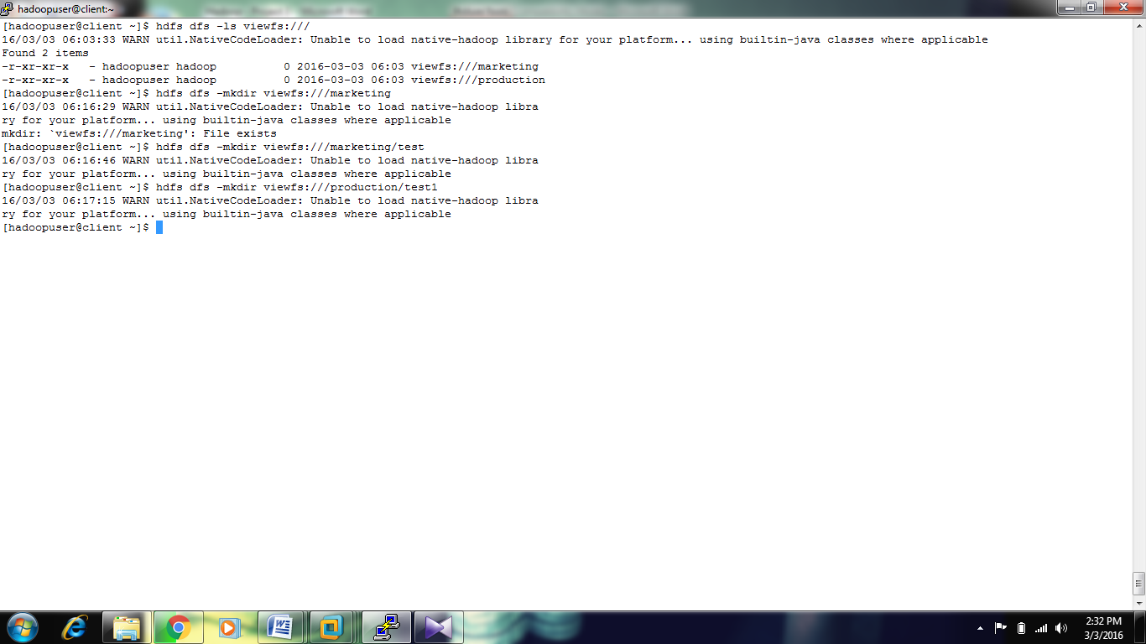
From NN1
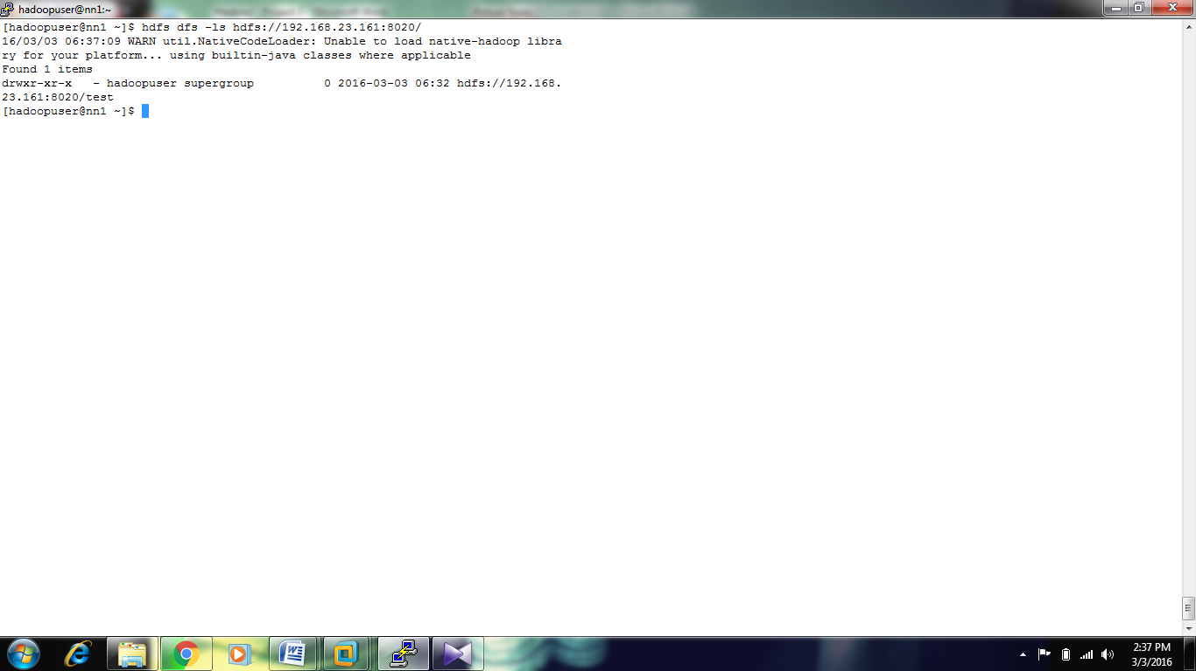
FROM NN2

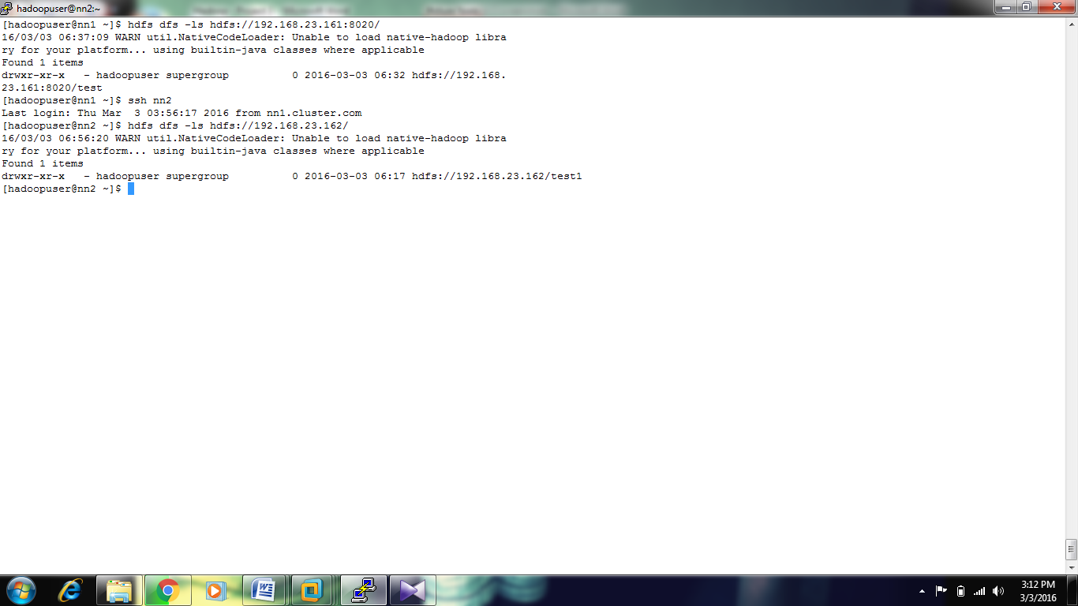

Putting data into marketing from client

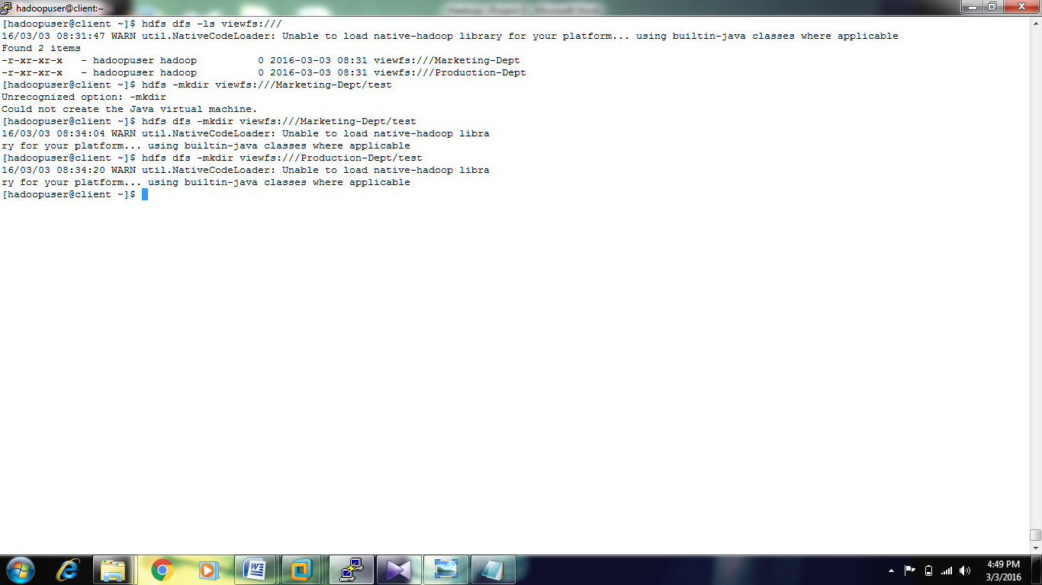

Client View

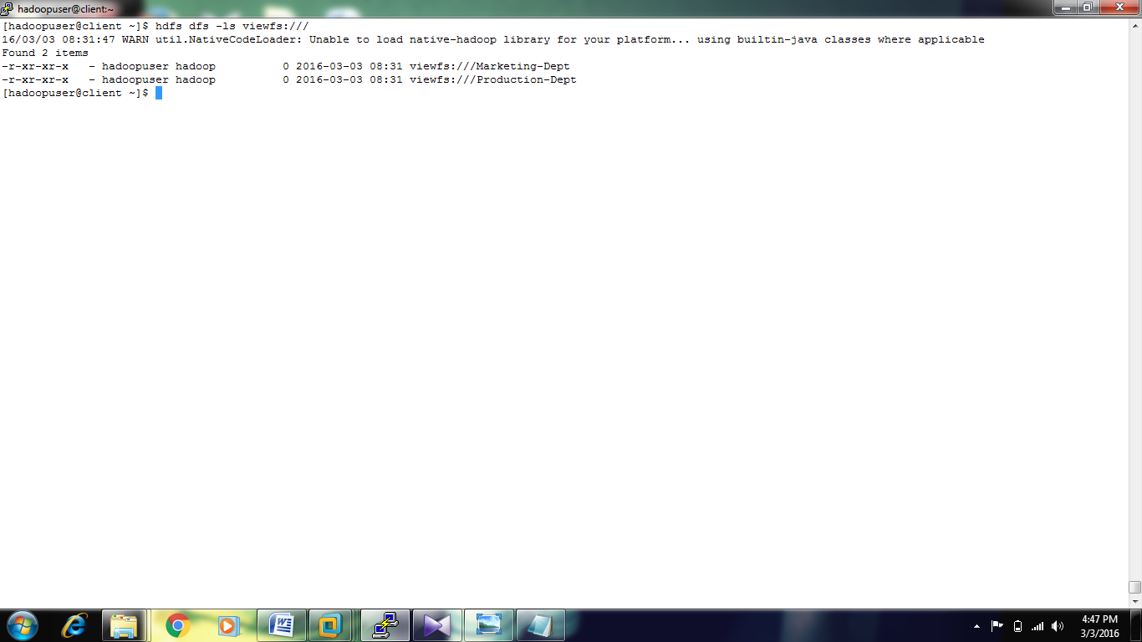

Killing one namenode:-

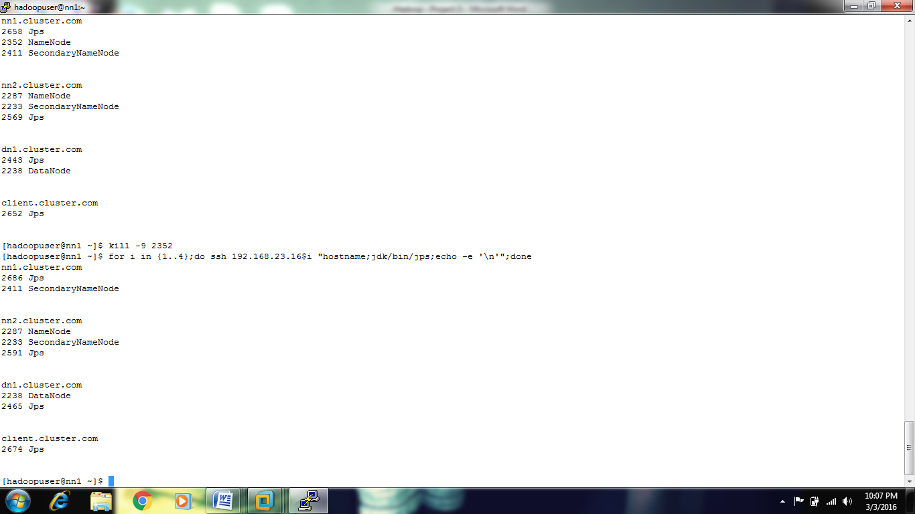

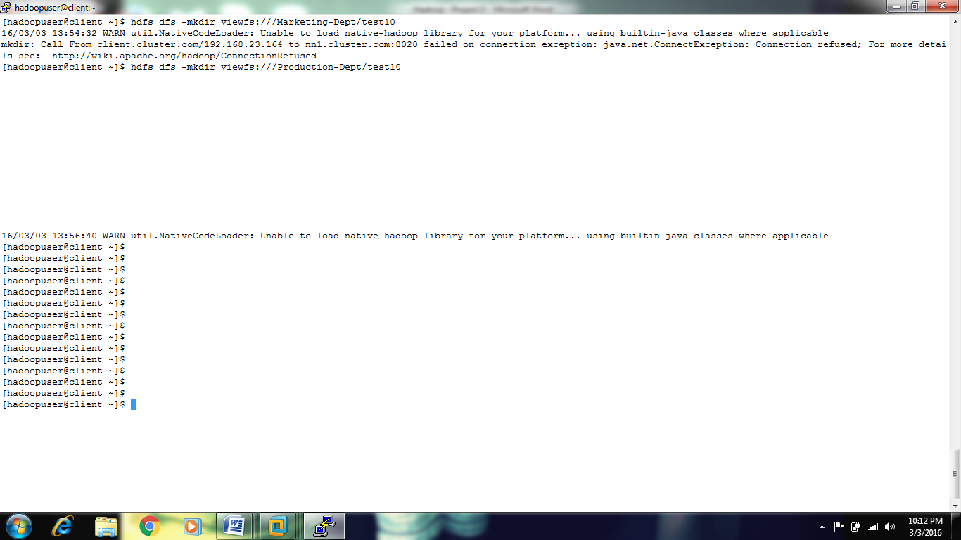

Both Namenodes are up and running
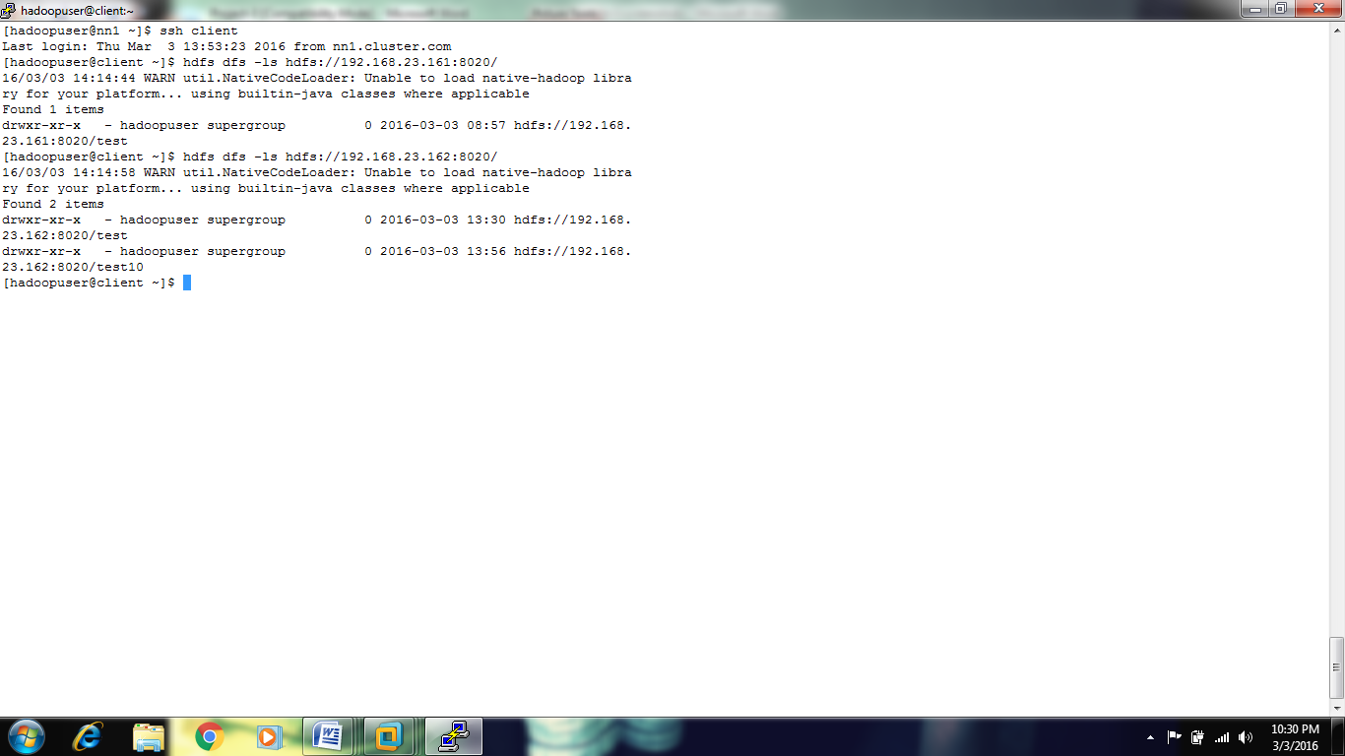

Web interface –NN1

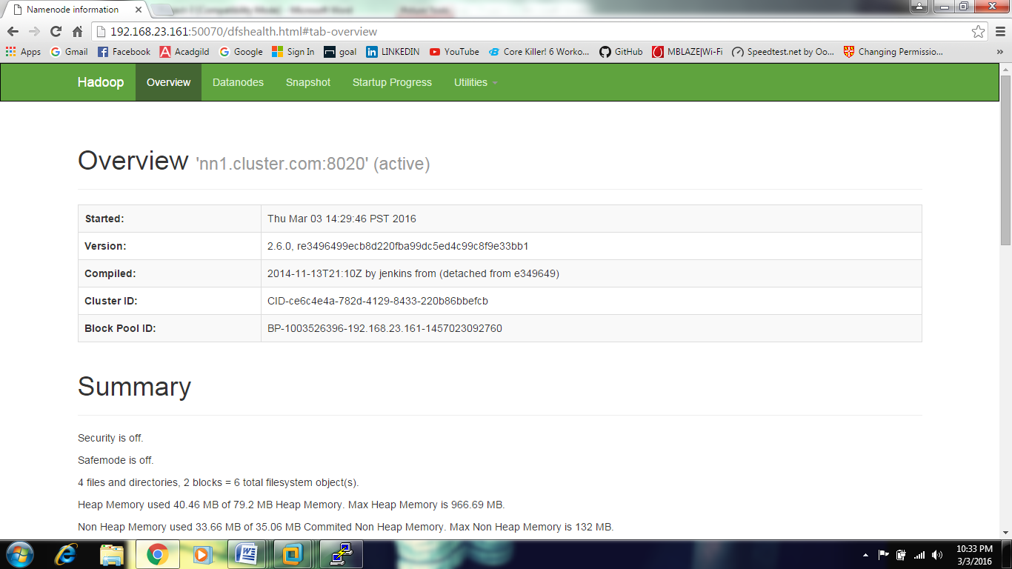

Web Interface –NN2

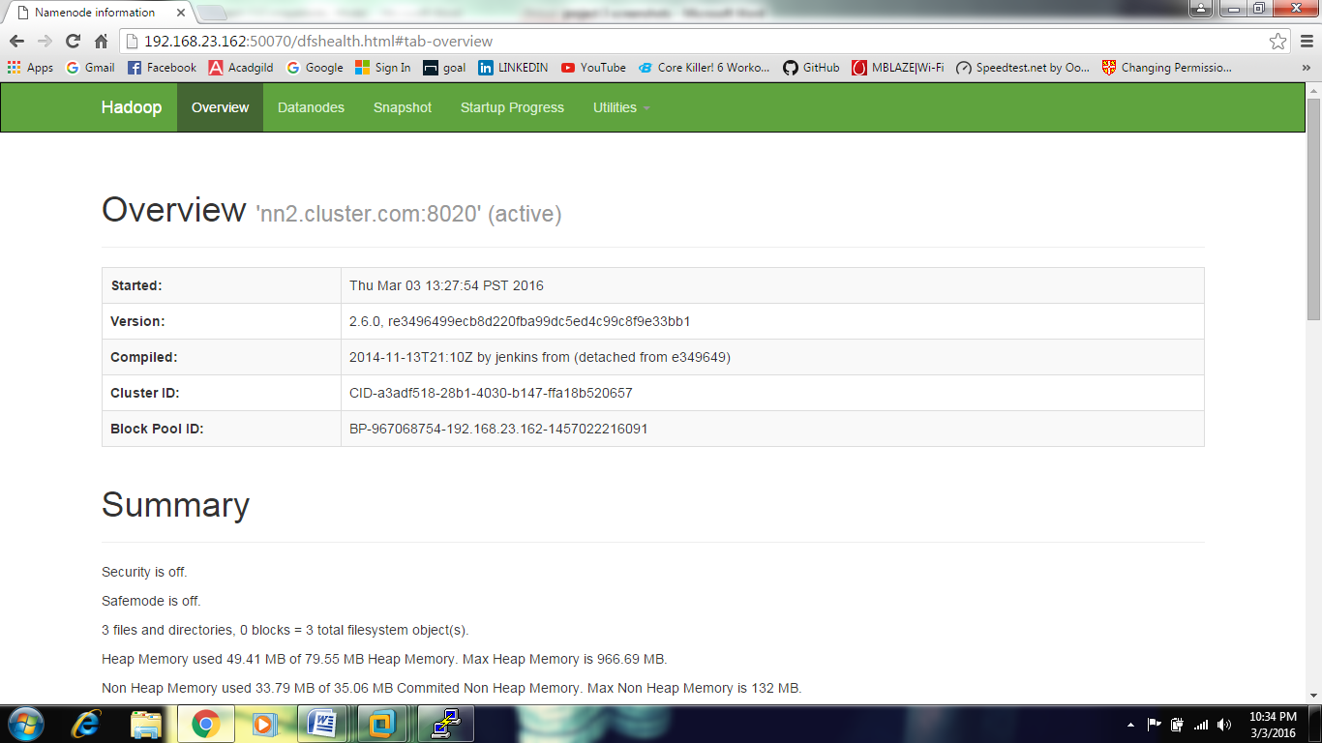

Database : sqooptest


Outputs:-

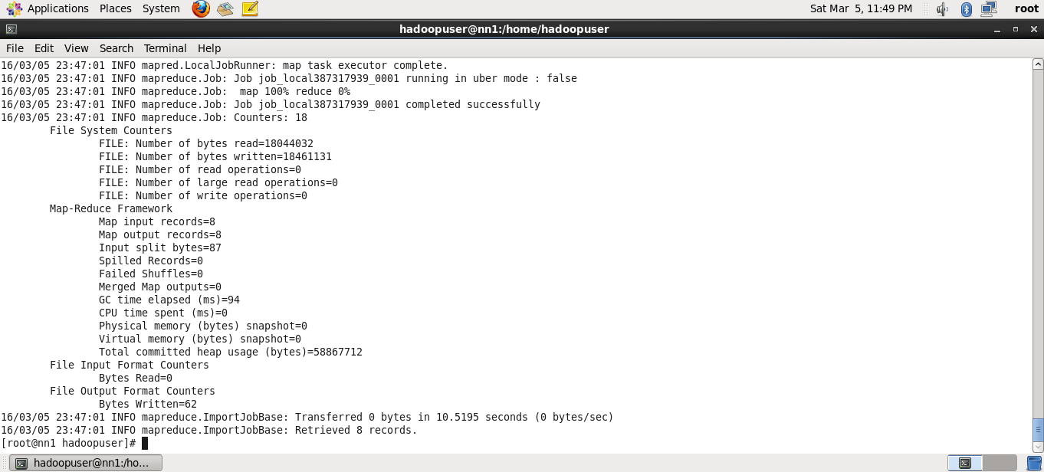



Where ( id >4)

